

Colebrook (South West) Ltd — Job Description
Community Centres Assistant
____________________________________________________________
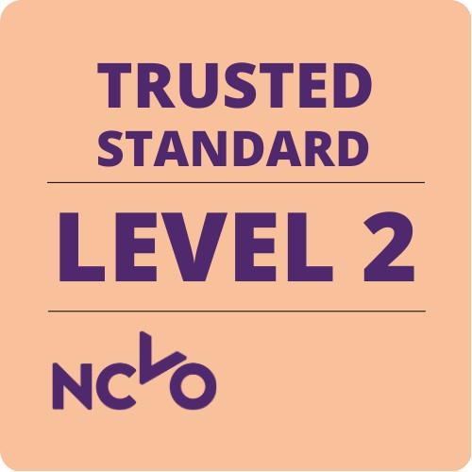


Unit 1 Endeavour House, Parkway Court, Marsh Mills, Plymouth, PL6 8LR
Tel: 01752 205210 | Email: recruitment@colebrooksw.org | www.colebrooksw.org

JOB TITLE: Community Centres Assistant
SALARY: £25,011.62 per annum, pro rata
PROBATION PERIOD: 6 Months
CONTRACT: Permanent
BASE: Colebrook South West Ltd Community Centres: William Sutton Memorial Hall (St Budeaux) & William Sutton Village Hall (Crownhill)
Due to the nature of the service, the post holder may be required to work at other Colebrook locations.
REPORTS TO: Engagement Services Manager
NOTICE PERIOD: One calendar month
HOURS: 25 hours per week to be worked flexibly according to organisational need. This will include weekend/occasional evening and early morning working for which no additional payment is made.
PENSIONS: Employees’ Pension Scheme available

INTRODUCTION
Colebrook have been working with individuals, communities and organisations in and around Plymouth for over 40 years and pride ourselves in putting people at the heart of everything we do.
Our mission is to inspire and empower people and communities to achieve their independence and aspirations. We achieve this through our services by:
• Supporting people to achieve skills, realise goals and improve independence
• Supporting community development and sustainable growth
• Involving people to have a voice and shape services.

OVERALL AIMS OF THE POST
Working with other members of the Community Centres Team/Colebrook Central Team support the day-to-day delivery of operations at Colebrook South West’s Community Centres.

DUTIES / RESPONSIBILITES:
- Conduct weekly Health & Safety and maintenance inspections of premises, ensuring buildings and grounds are well-maintained and kept clean and tidy.
- Working with the Caretaker support the cleaning of all areas of Colebrook South West’s Community Centres including all main rooms, kitchen and toilets.
- Oversee/Conduct weekly fire alarm tests at both sites, record findings and promptly reporting issues.
- Carry out RAMS (Risk Assessment and Method Statement) as required, maintaining a register of identified risks.
- Maintain a list of routine/emerging maintenance and redecoration tasks as identified at each centre.
- Liaise with Clarion Estates Team as required for all maintenance tasks that fall under their remit.
- Support the Caretaker with maintenance and redecoration tasks as per the maintenance schedule. This may include moderate to heavy physical work, outside, in all weathers in a safe manner.
- Ensure all consumables, cleaning materials and other chemicals are well stocked, stored and used correctly in line with COSHH requirements.
- To set up and clear rooms for a variety of functions including putting up and storing tables, chairs and other equipment.
- Coordinate deliveries and facilitate site visits as needed, contributing to smooth operations.
- With support from the Caretaker, undertake low level maintenance tasks at Colebrook Supported Accommodation Projects
HEALTH & SAFETY
- To perform all duties in a manner which ensures the health, safety and welfare of both you and those who use the Community Centres, in adherence with policy, practice and procedure.
GENERAL:
- To undertake other duties that may reasonably be required by the Chief Executive, MT and Board of Directors.
- To comply with all aspects of the policies and procedures of Colebrook in accordance with legislation and good practice, complying with General Data Protection Regulations and the Data Protection Act requirements and promoting equality and diversity.
- To remain active and involved in personal development opportunities, training and participate in supervision and performance appraisals as required.
- To promote open and honest communication and to work as part of the Team.
- The position is designated as an essential driver. The post holder must have own transport to travel to various Community Centre/Colebrook Services locations to carry out duties.
Please Note: All job descriptions are reviewed on an ongoing basis. There is an expectation that all the above duties / tasks can be performed by an employee to meet the changing needs of services and / or clients.

COLEBROOK (SOUTH WEST) LTD

Person Specification – Community centres Assistant
PLEASE NOTE: Each application will be assessed against the criteria that are essential for this post and it is on this basis that applicants will be short listed for interview. It is therefore vital that these criteria are clearly demonstrated both on your application and at an interview.
Qualifications & Training
Essential
- General education to GCSE/O level standard or equivalent, including English and Maths
- Health & Safety Qualification
- Clean full driving licence (with vehicle available for work)
Experience & Knowledge
Essential
- Ability to communicate effectively both verbally and in writing with a broad range of volunteers, professionals and members of the public
- General customer service and admin experience
- Experience of basic general handyperson duties and/or working in a maintenance environment
- Experience of working within and taking responsibility for own health and safety

Desirable
- Knowledge of Microsoft 365 including Sharepoint & Teams
- Previous experience of working within a Community Centre environment
- Experience of working with volunteers or volunteering

Skills & Competencies
Essential
- Be able to safely lift, carry, and move equipment and loads, with reasonable adjustments if required
- Strong communication skills, both verbal and written

Desirable
- Knowledge of fire safety regulations advantageous
- First Aid qualification
- Working at height experience beneficial

Individual Qualities
Essential
- Be able to communicate effectively
- Be able to develop and maintain good working relationships
- Be able to work on own initiative and unsupervised
- Willingness to work flexibly where required
- Ability to work in a fair and non-discriminatory manner.

 | Full Name | Signature | Date
Service Manager
Post holder

